How to Share a Calendar between PRH and RHW
*can share full details
*can NOT make edits to calendar between RHW and PRH since they are separate organizations

Instructions – for person sharing their calendar
- Open outlook
- Go to calendar tab (bottom left, calendar icon)
- Once in calendar, go to home tab on the top toolbar
- Select publish online
- Select configure this published calendar
- Microsoft 365 should open up online
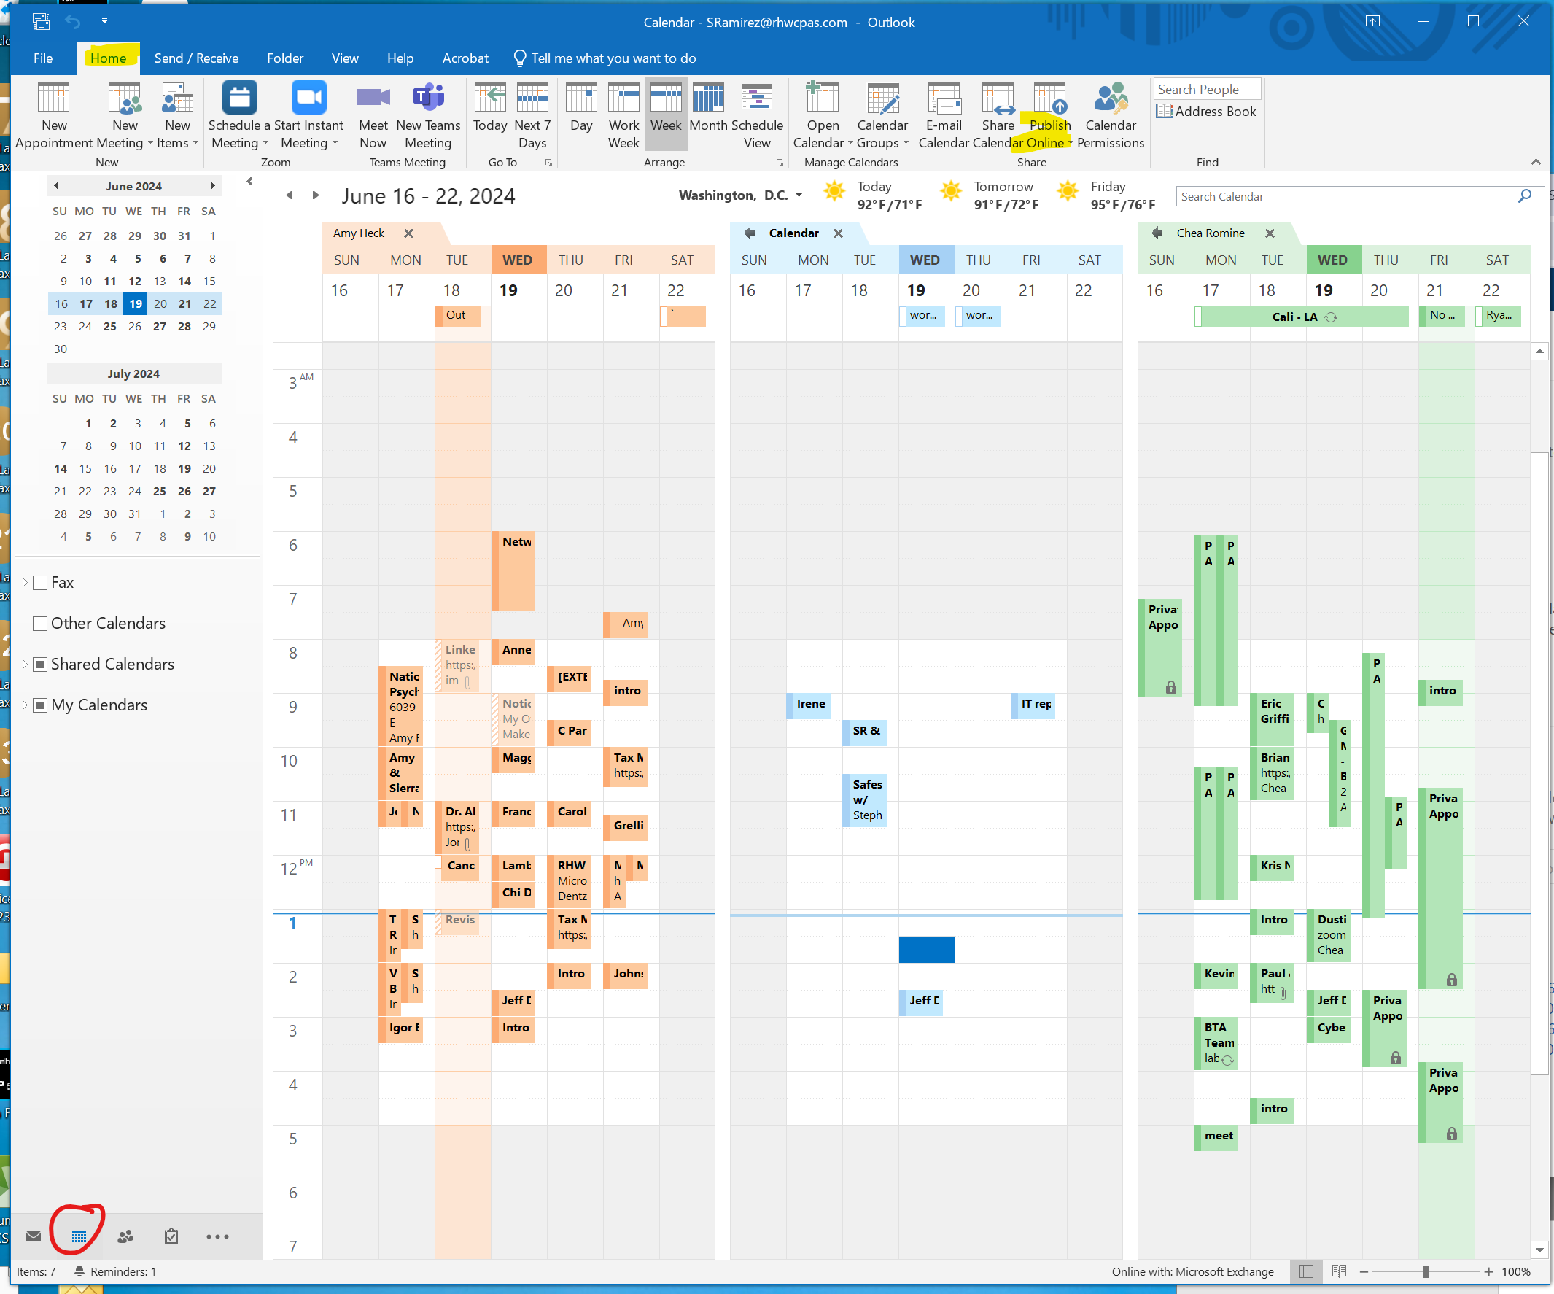
- Settings screen will open for shared calendars
- In the publish a calendar section select
  - The calendar from drop down #1
  - The desired permissions from drop down #2
- Click publish
- Copy the ICS link and send to individual you are trying to share calendar with
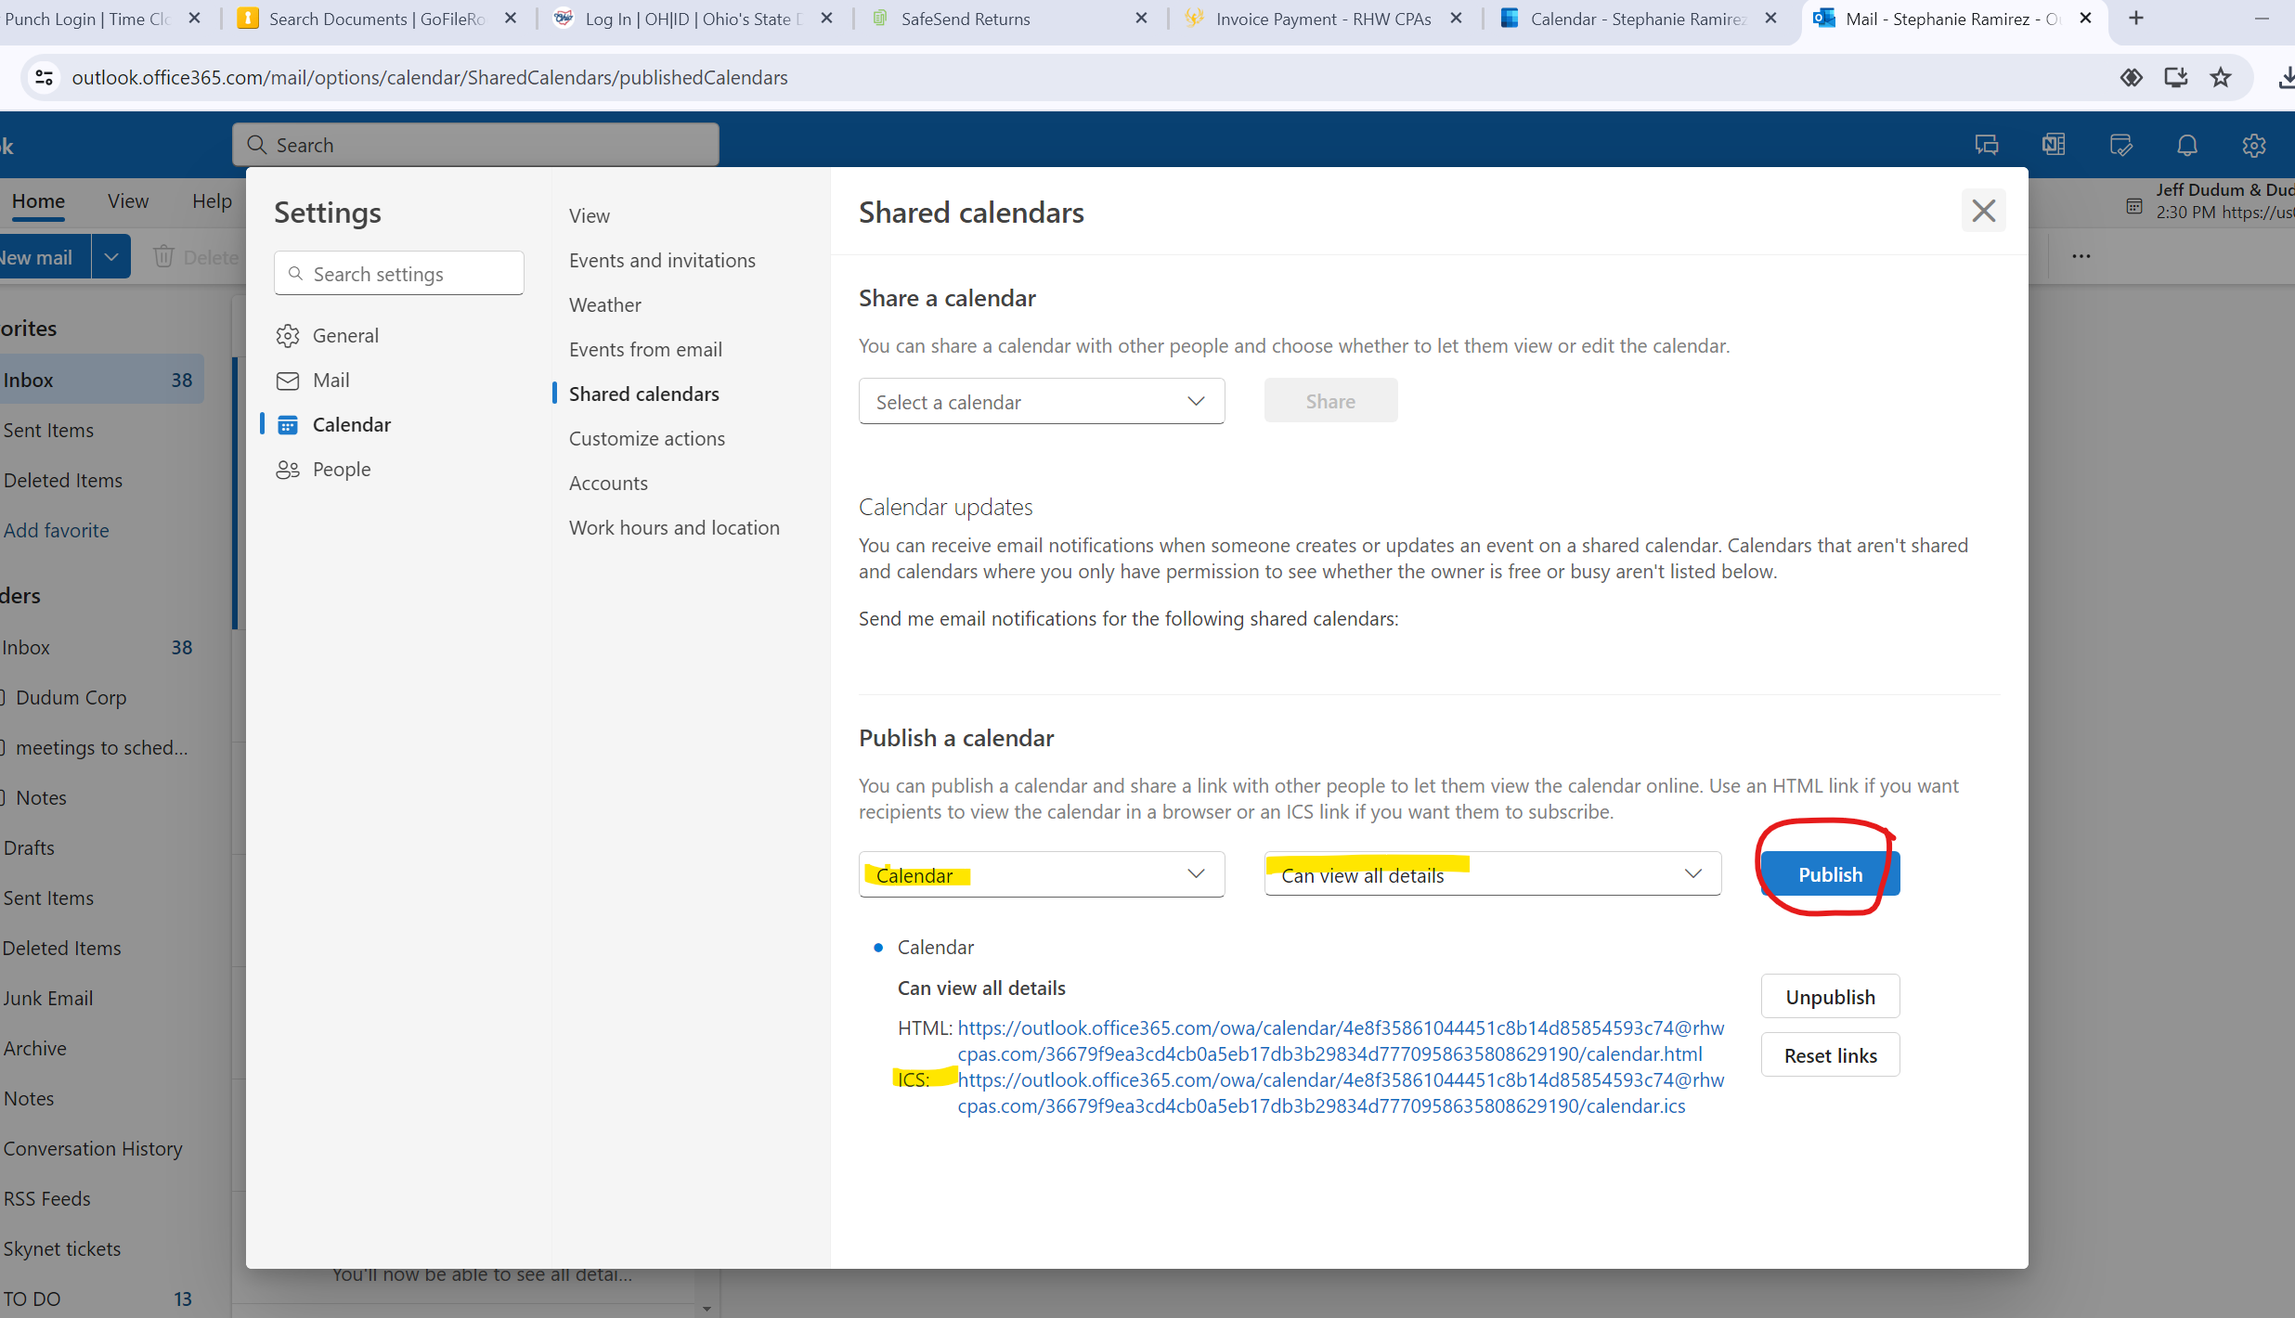

Instructions – for person adding shared calendar
- Open outlook
- Go to calendar
- On home tab, select open calendar
  - Open from internet
  - Add link to new internet calendar subscription and click ok
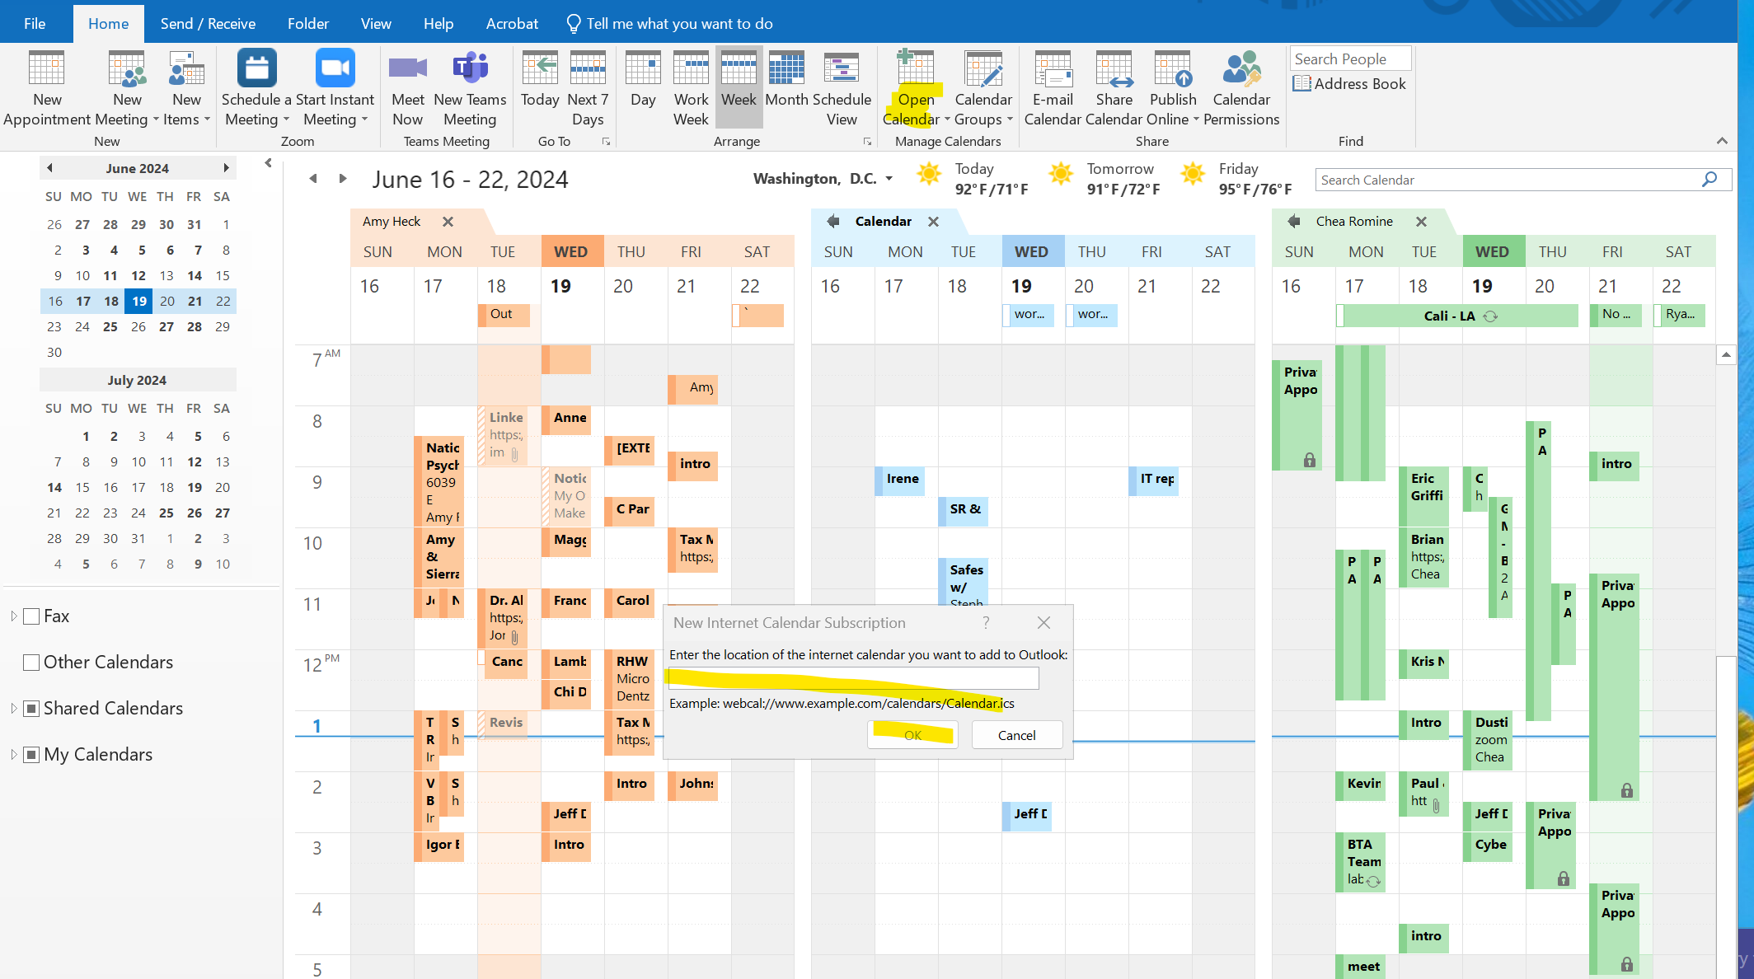

- New calendar should show up either in shared calendar or my calendar (left toolbar)
- Select calendar name to view
- You will be able to view full details even if calendar is from a different organization, but you will NOT be able to add / delete to that calendar

If you are trying to schedule a meeting for a PRH employee, you can view their calendar to schedule the appointment with a client but will need to notify that staff member of the meeting so they can add it to their calendar and send the invitation to the client.

You can also send a meeting invitation via Teams.
- Open teams
- Select Calendar on the left toolbar
- Select + new meeting (top right)
- Enter meeting details and click save

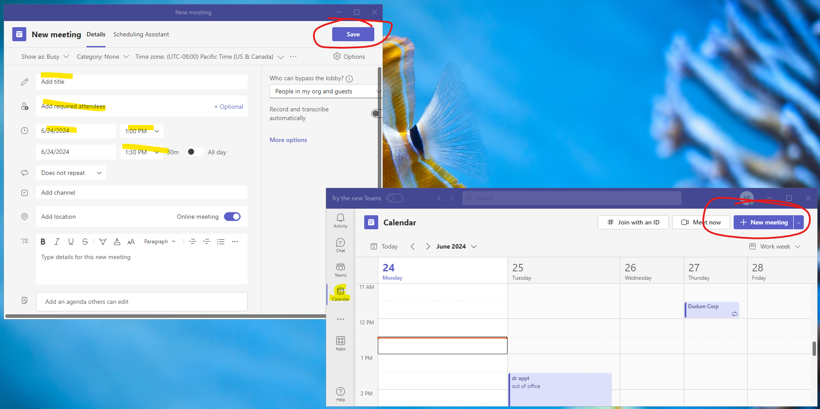

A few things to note about creating appointments this way.
- If sharing within the same organization, you’ll be able to see the appointment on the other person’s calendar but it will be greyed out.
- If sharing between different organizations, you won’t be able to see the appointment on the other person’s calendar until they have accepted.
- You’ll receive an email confirmation once the meeting is accepted.
- The meeting will also pop up on your calendar. (no way around this at the moment).

